Project Design Phase-II
Technology Stack (Architecture & Stack)

Date | 31 August 2026
Project Name | Automated Network Request Management in ServiceNow
Maximum Marks | 4 Marks

Technical Architecture:
The architecture of Automated Network Request Management in ServiceNow consists of users, Service Catalog, application logic, Flow Designer, approval management, notifications, and the ServiceNow database.
The user submits a network request through the Service Catalog. The system collects and validates the required information, creates a request record, and sends it for approval. After approval, the request is processed and assigned to the appropriate team. Flow Designer automates the workflow, record updates, and notifications. All request information is stored in the ServiceNow database for tracking and management.
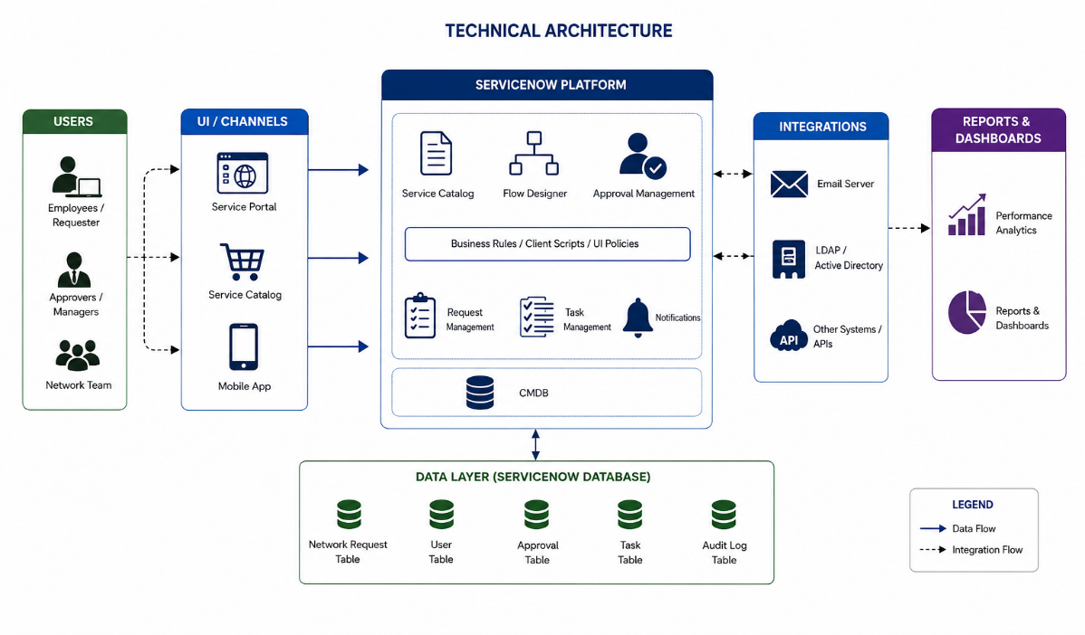
Employee / Requester ↓
↓ Request Processing
Service Catalog ↓
↓ Status Update
Network Request Form ↓
↓ Email Notification
Client Scripts / UI Policies ↓
↓ Request Completed
Network Request Record
↓
Approval
↓
Flow Designer
↓
Network Support Team
Main Components
Component | Technology / ServiceNow Feature
User Interface | Service Catalog
Request Form | Catalog Item & Variables
Form Validation | Client Scripts & UI Policies
Request Management | Custom Network Request Table
Automation | Flow Designer
Approval | ServiceNow Approval
Task Management | ServiceNow Tasks
Notification | Email Notifications
Data Storage | ServiceNow Database
Reporting | ServiceNow Reports

